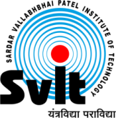
Sardar Vallabhbhai Patel Institute of Technology Vasad

Aeronautical Engineering Department
Aeronautical Engineering Department had organized an expert talk on Technical Aspects, challenges and futuristic in UAV design on 7th March, 2022. The students of Aeronautical Engineering, were benefitted through interact with an invited expert, Dr. Rajkumar S Pant, Professor, IIT Bombay. Approximately 100 participants were benefitted from this workshop. The session was very informative and interactive. Sir had covered classifications, types and applications of UAVs in detail. The recent research projects and future in UAVs was also discussed. The job opportunities and requirements from Aeronautical Engineers in Indian industries with drones’ market and capabilities were nicely delivered. Pant sir had spare his time in technical discussion with final year students’ on their ongoing project.
Event Photographs:

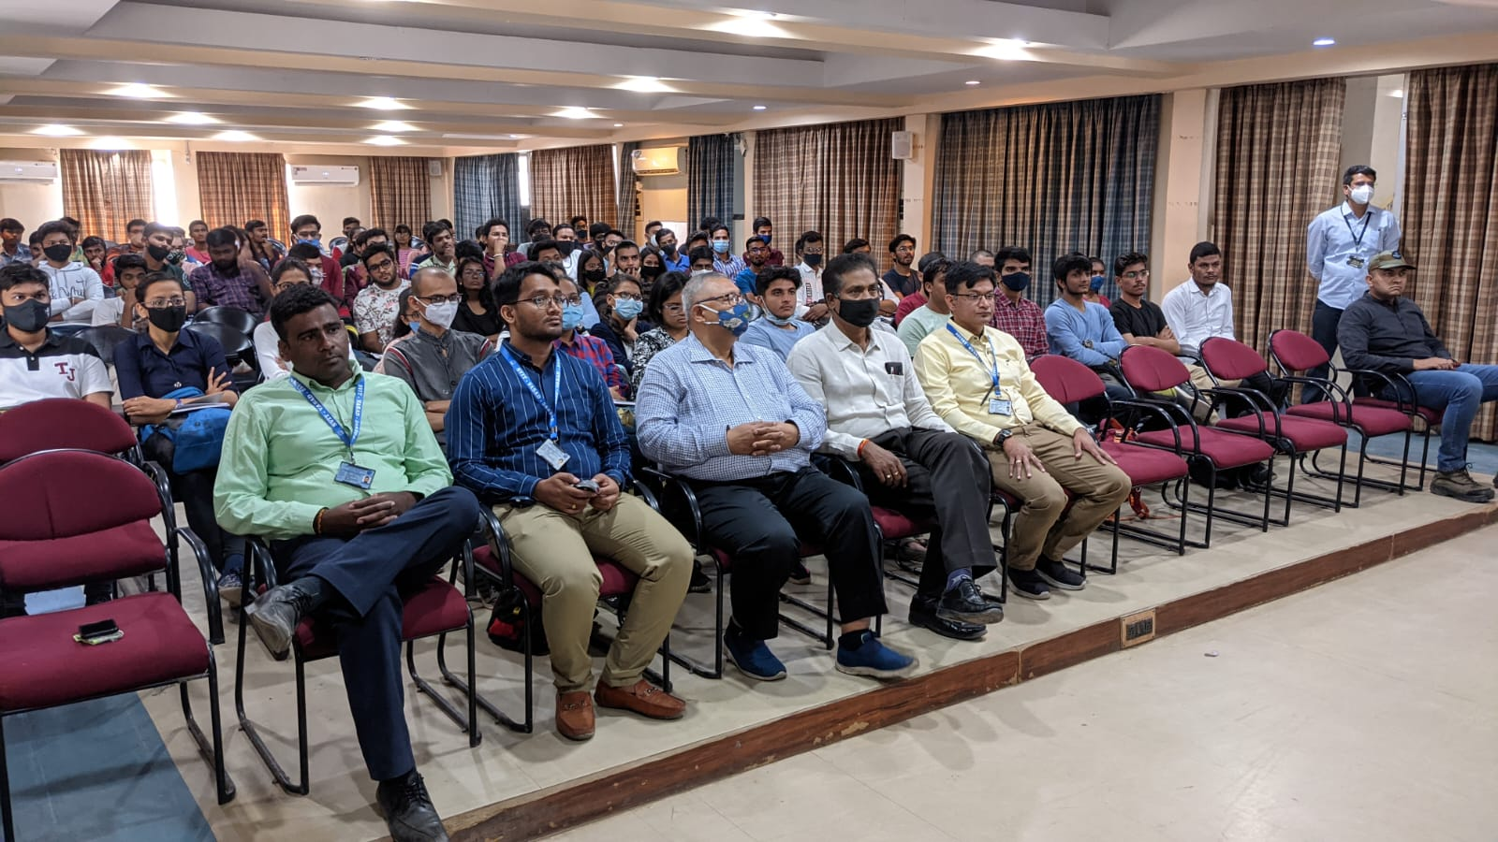
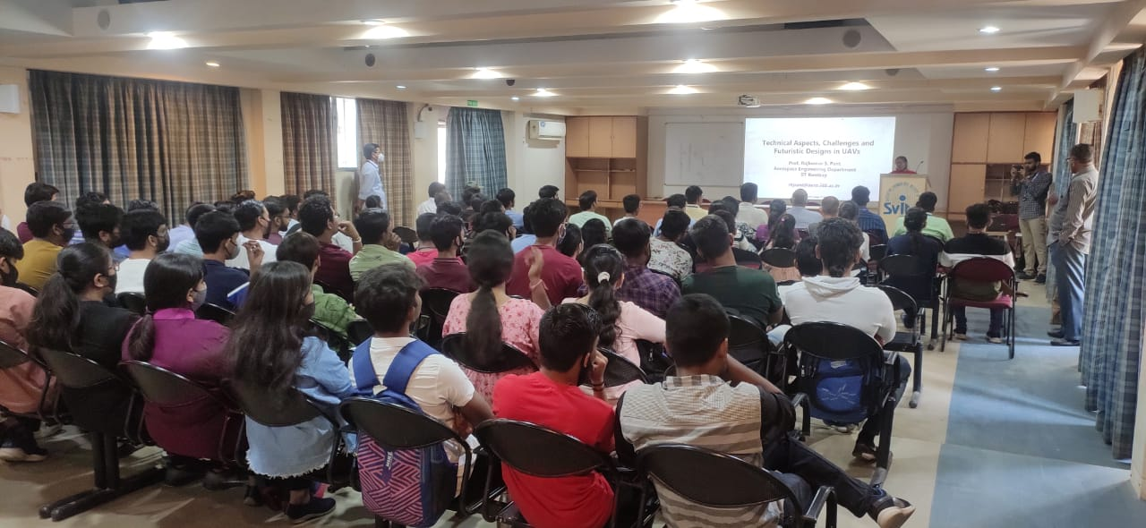
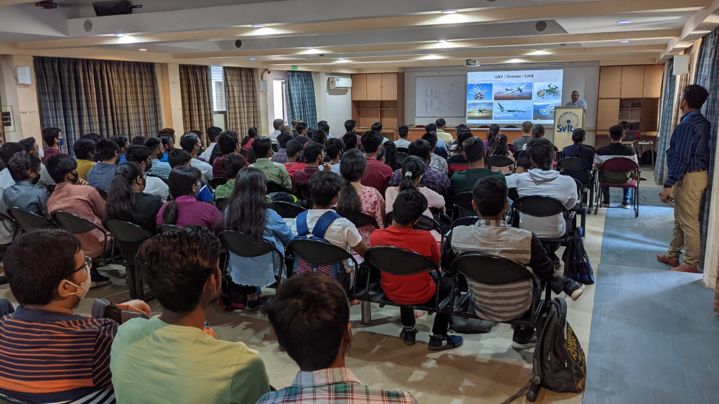

The overall session was very good and very informative. 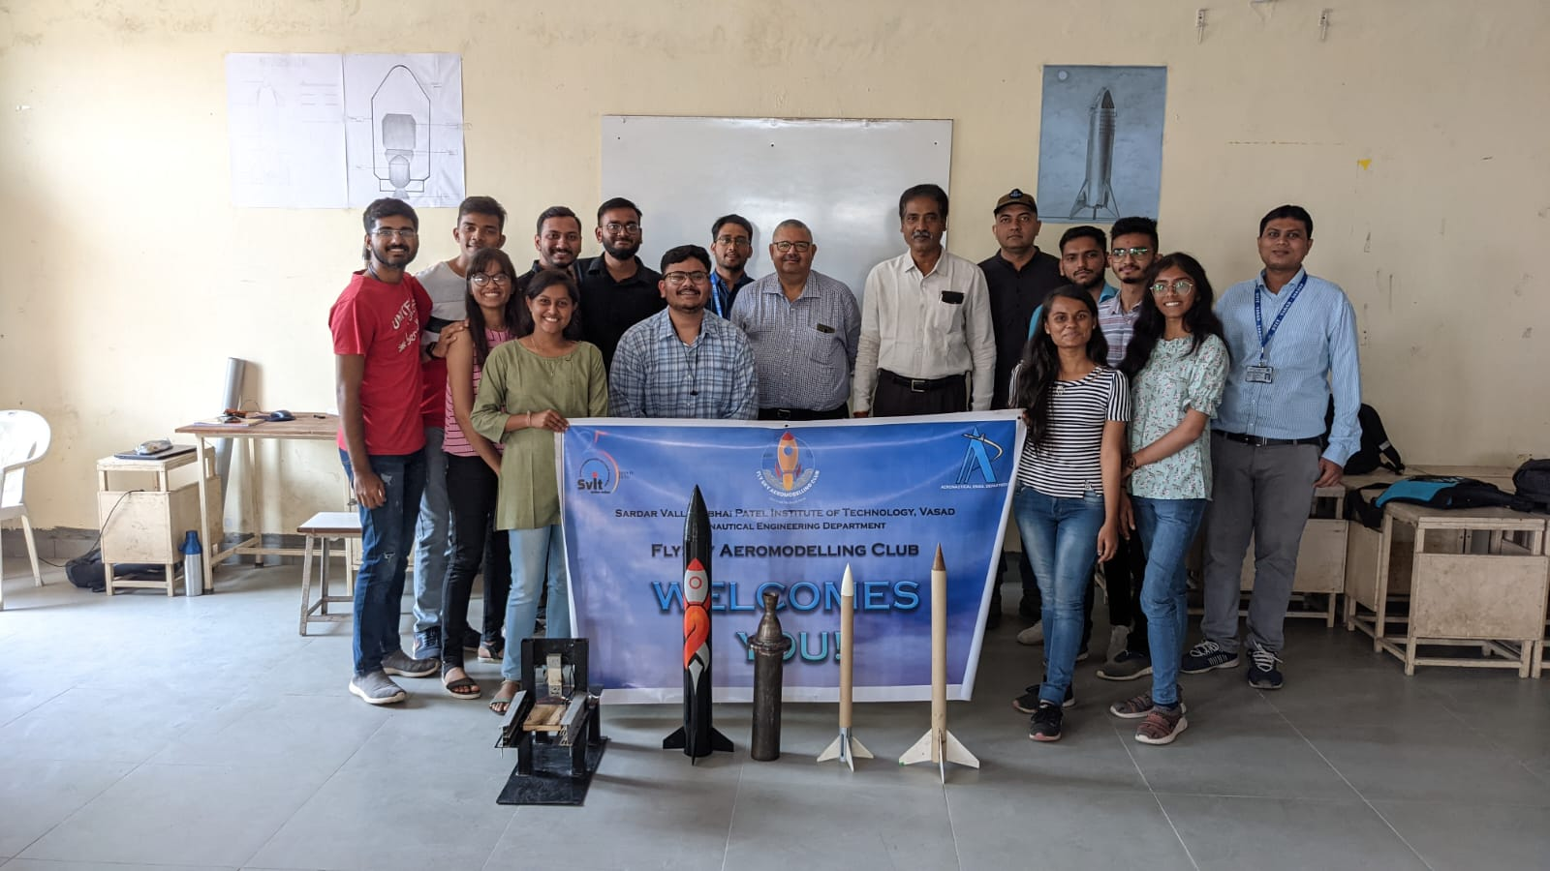
Thank You.

.
Dr. P V Ramana | Faculty co-ordinator  Niyati Shah
Professor and Head  Aeronautical Engg. Dept  SVIT Vasad | Assistant Professor  Aeronautical Engg. Dept.  SVIT Vasad

