Date: 22/09/2022
To
The Principal,
S.V.I.T. Vasad

Sub.: Report on Industrial Visit to VSSE - ISRO, Ahmedabad.
Respected Sir,
A visit to the Vikram Sarabhai Space Exhibition Centre, Ahmedabad was very interesting and beneficial to the first year students of Aeronautical, Mechanical and E&C engineering. After reaching at VSSE at 10:30 am we were briefed about the activities of ISRO and Space Application Centre, Ahmedabad. Students were explained about the success path of ISRO, private sectors, emerging techniques and future missions of ISRO.
Vikram Sarabhai Space Exhibition Centre was very fruitful for the students in terms of visualization of scaled up models various satellites, rockets and missiles. The communication and navigation systems were explained well by ISRO officials.
An insight into all the components and parts which integrate to make up the launch vehicles, satellites and rockets were explained. Launch missions of Chandrayaan and Mangalyaan were also explained. A detailed description of GSLV Mk III, Mangalyaan and Gaganyaan were explained to the students.
Overall, it was a successful visit for 56 students from First year.
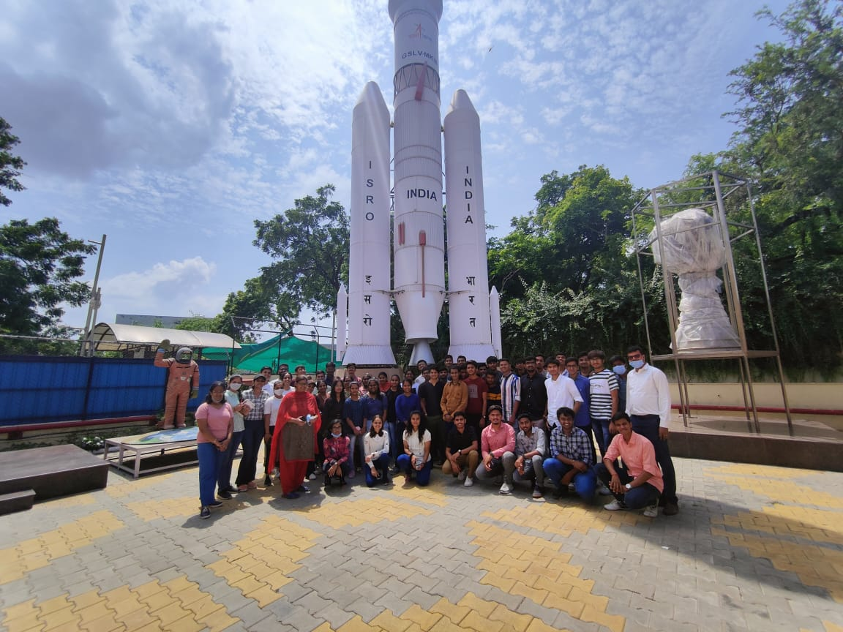

Prof. Niyati Shah Prof. Jigar Sura
Assistant Professor Assistant Professor
Aeronautical Engineering Aeronautical Engineering
SVIT, Vasad SVIT, Vasad

