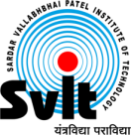
Sardar Vallabhbhai Patel Institute of Technology, Vasad

Aeronautical Engineering Department

Date: 26/04/2020
Report of Webinar on

“Career guidance in the field of Aerospace Engineering”

Aeronautical Engineering Department had organized webinar on “Career guidance in the field of Aerospace Engineering” 26 April, 2020 for all aeronautical engineering students and 12th standard school students. The Expert, MR. Mitesh Patel, Boeing Company, USA addressed the session. This webinar was organized from 05:00 p.m. to 06:30 p.m. Approximately 100 participants were benefitted from the Webinar.

The following points were highlighted during the session.
- Higher Studies in India & Abroad
- Career opportunities for Aerospace Engineers
- Essential Skills one should learn
- Importance of Academic Knowledge
- Future of Aviation in USA, Canada & India

Photographs of Events:
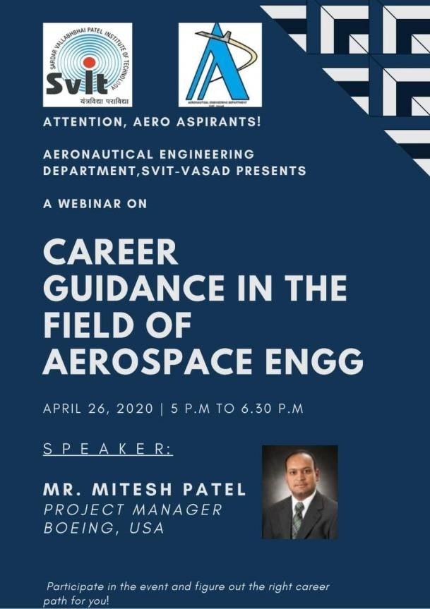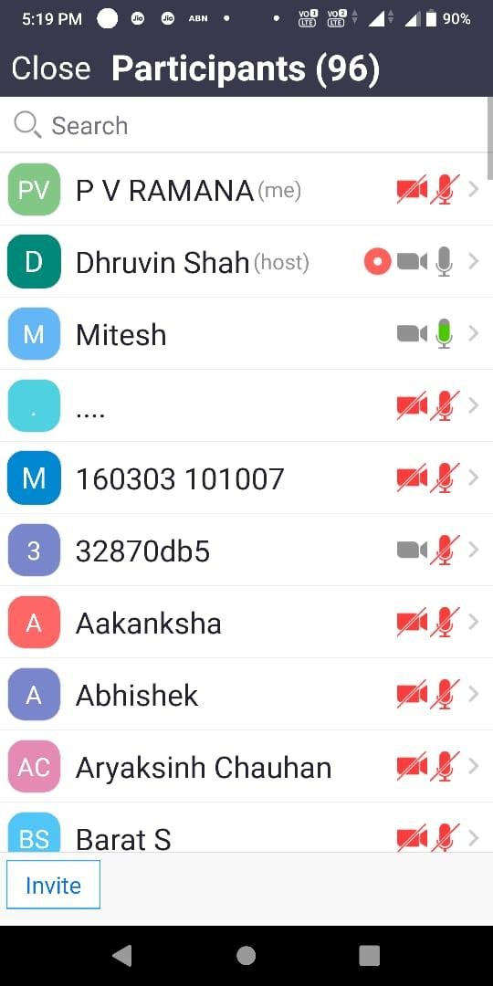

The overall session was very fruitful and informative. Thank You & Regards

Faculty Coordinator
Aeronautical Engineering Department Prof. Dhruvin Shah
Assistant Professor,
SVIT -VASAD
H.O.D.
Aeronautical Engineering Department Dr. P V Ramana
Professor
SVIT-VASAD

