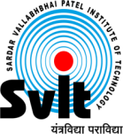
Sardar Vallabhbhai Patel Institute of Technology, Vasad

Aeronautical Engineering Department

Date: 06/05/2020

Report of Webinar on

“Xplore the Space”

Aeronautical Engineering Department had organized webinar on “Xplore the Space”
on 4th May 2020 at 5:00 PM for Engineering students. Where Aeronautical Engineering Department (SVIT) alumnus Dr. Rushi Ghadawala who has been working as an Executive Chairman in the B R Aerospace Group, CANADA, Addresses Session. He guided and interacted with students as well as faculty members. It was a great opportunity for students as well. This was a very fruitful and informative session. The overall session was very good, and from this session, students got knowledge regarding Space.

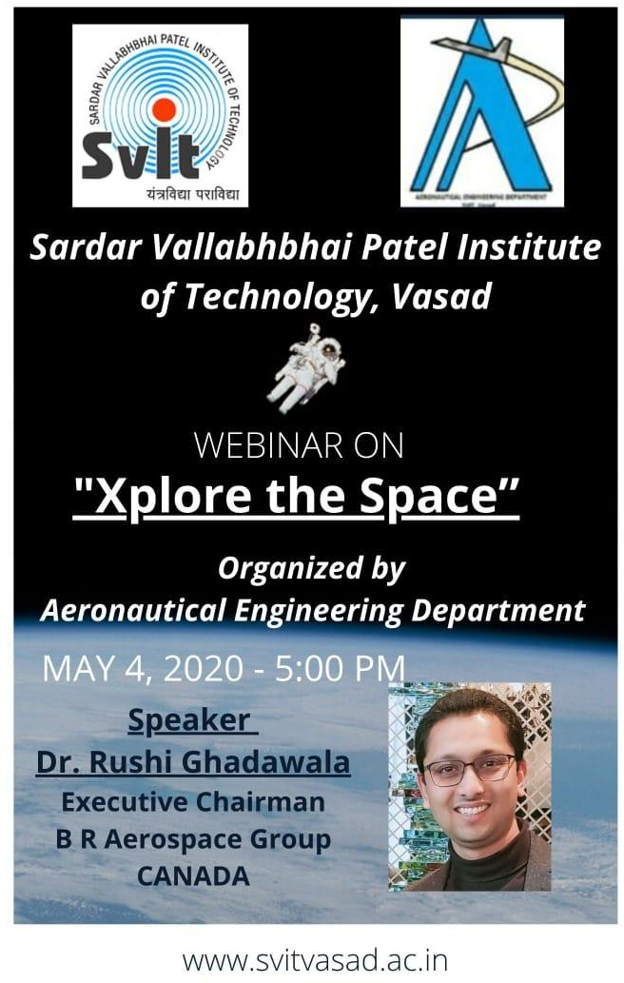

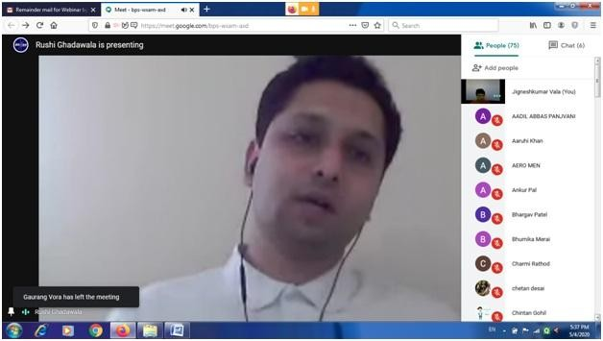

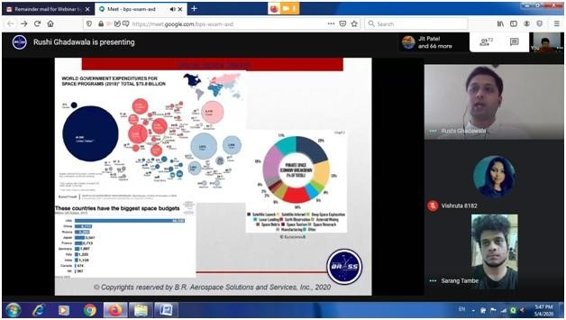

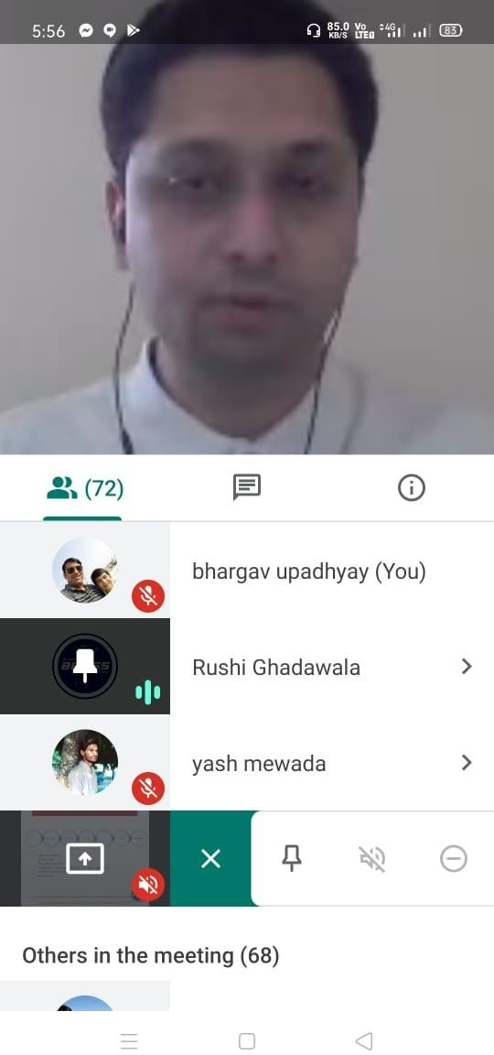

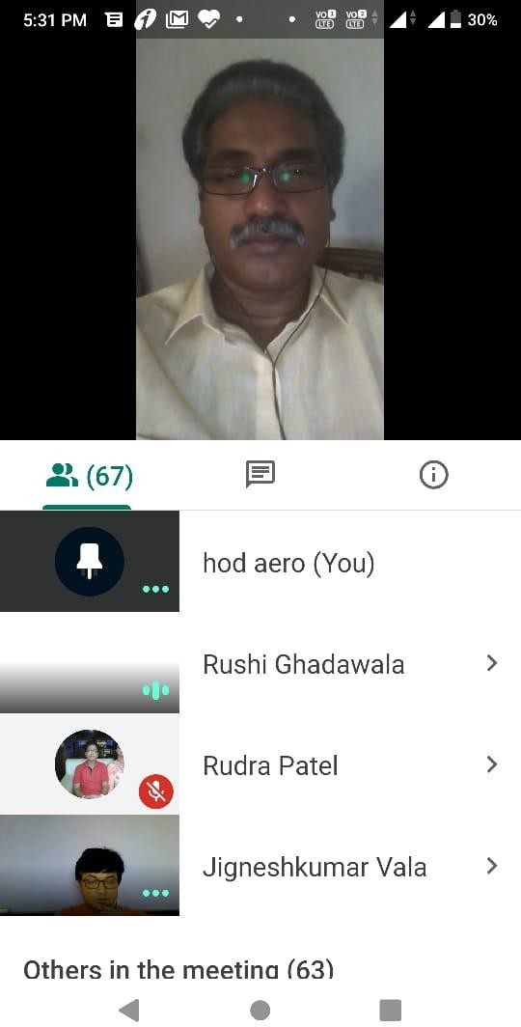

Organized By Dr. P V Ramana
Prof. Jignesh Vala HOD, Aeronautical Department Assistant Professor SVIT, Vasad
Aeronautical Department SVIT, Vasad

