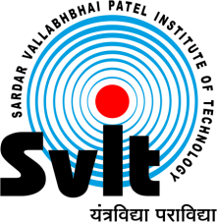
Sardar Vallabhbhai Patel Institute of Technology , Vasad

Aeronautical Engineering Department

Date: 10/05/2020

Report of Webinar on

“Important tools in the field of Design for Aeronautical / Mechanical Engineers”
Aeronautical Engineering Department had organized webinar on “Important tools in the field of Design for Aeronautical / Mechanical Engineers”
(Hands on Training using ANSYS-Fluent) on 9th May 2020 at 5:00 PM to 6:30 PM for Engineering students. Mr. Anand Darji, Ph.D Scholar at Department of Mechanical Engineering, SVNIT Surat (2019 onwards) and also associated with a consulting firm Techsolve Engineering Solutions as a CFD Consultant Engineer, Vadodara, Addresses Session.

He guided and interacted with students regarding Topic. It was a great opportunity for students as well. This was a very fruitful and informative session. The overall session was very good, and from this session, students got knowledge regarding CFD Field.
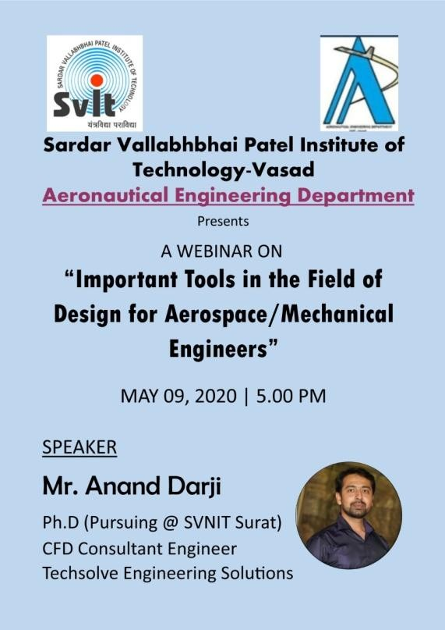

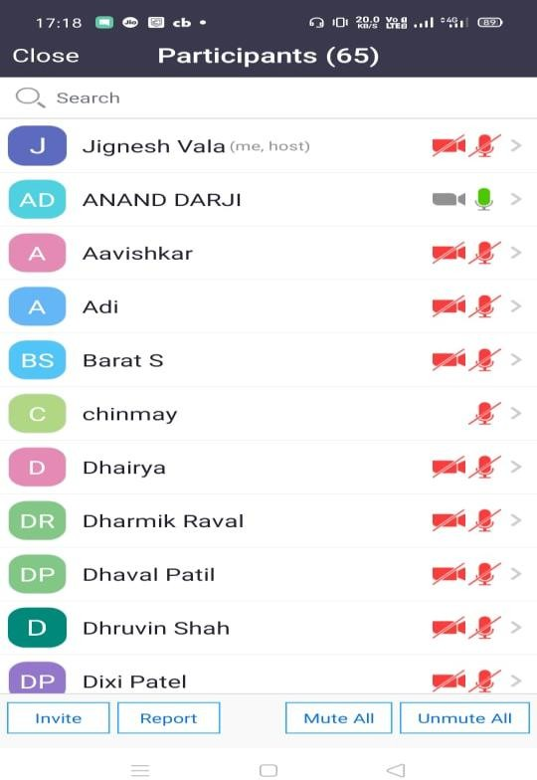

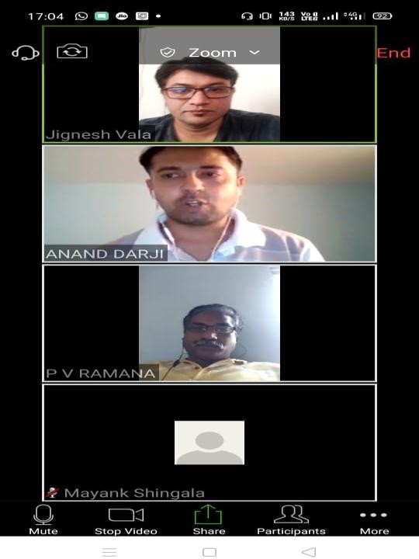

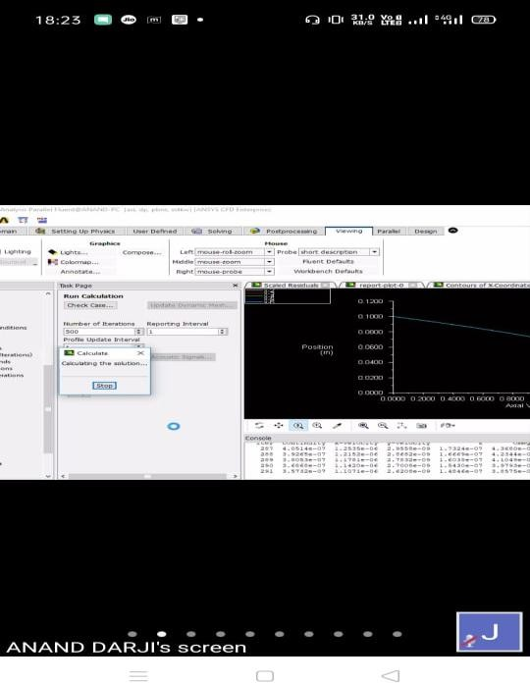

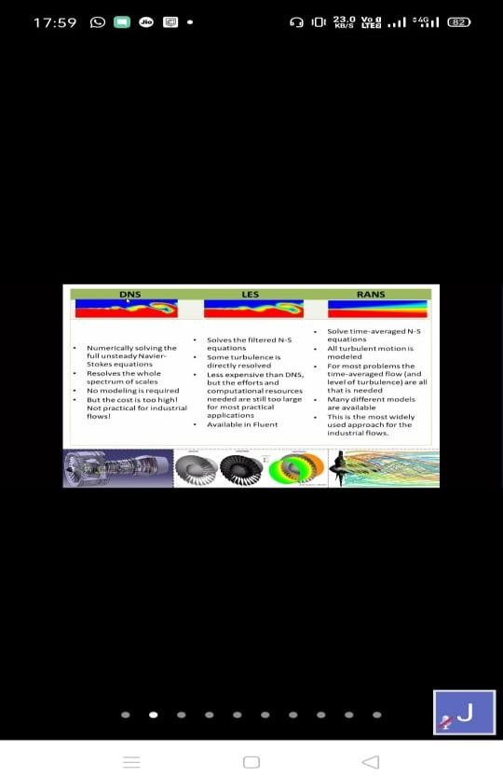

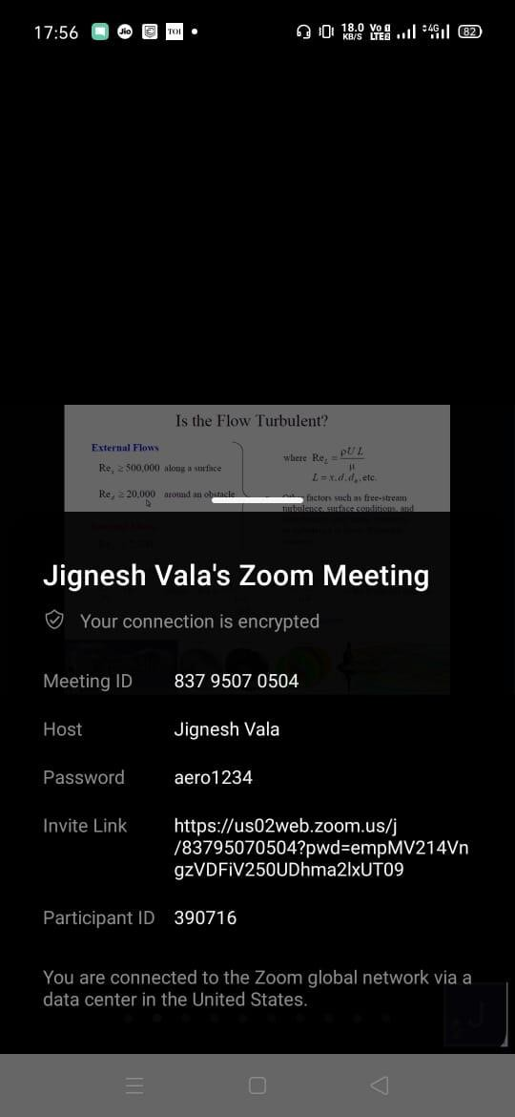

Organized By Dr. P V Ramana
Prof. Jignesh Vala HOD, Aeronautical Department Assistant Professor SVIT, Vasad
Aeronautical Department SVIT, Vasad

