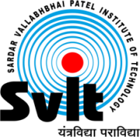
Sardar Vallabhbhai Patel Institute of Technology, Vasad

Aeronautical Engineering Department

Date: 11/05/2020
Report of Webinar on

“CONFIGURATION AND DYNAMICS OF SPACE SHUTTLE”

Aeronautical Engineering Department had organized webinar on “Configuration and Dynamics of Space Shuttle” May 10, 2020 for all aeronautical engineering students. The Expert, Mr. Pon Maa Kishan A, Assistant Professor, Aerospace Engineering, Chandigarh University addressed the session. This webinar was organized from 11:00 a.m. to 12:30 p.m. Approximately 50 participants were benefitted from the Webinar.

The following points were highlighted during the session.
- Winged re-entry vehicles (RV-W’s)
- Re-Usable Launch Vehicle - ISRO
- Space Shuttle Orbiter
- Vehicle Flyability and Controllability
- Flap Deflection Modes during Hypersonic Flight
- Onset Flow of Aerodynamic Trim and Control Surfaces
- Thermal – Mechanical Fluid – Structure Interaction

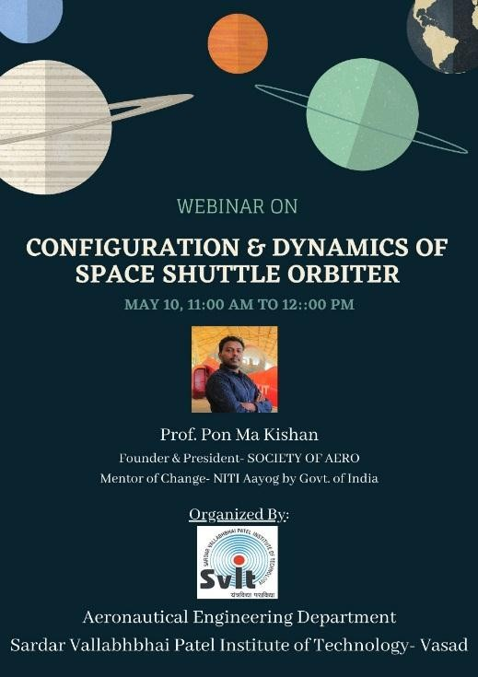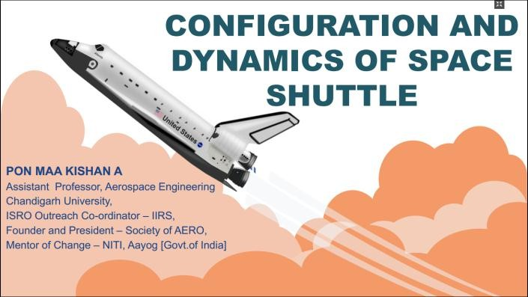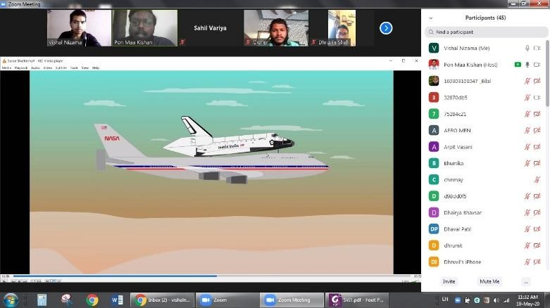Photographs of Events:

The overall session was very fruitful and informative. Thank You & Regards

Faculty Coordinator
Aeronautical Engineering Department Prof. Dhruvin Shah
Assistant Professor,
SVIT -VASAD
H.O.D.
Aeronautical Engineering Department Dr. P V Ramana
Professor
SVIT-VASAD

