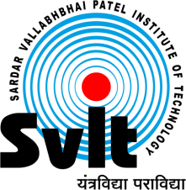
Sardar Vallabhbhai Patel Institute of Technology, Vasad

Aeronautical Engineering Department SVIT-VASAD

Aeronautical engineering department, SVIT Vasad has successfully organized Webinar on "Recent trends in Aircraft Propulsion" where SVIT alumnus Mr. Nishit Mehta who has been working as Lead Engineer in Question Global Engineering Services pvt. Ltd. addressed session. He guided and interacted with students. It was a great opportunity for students as well. This was a very fruitful and informative session. Approximately 50 participants were benefited from this webinar.
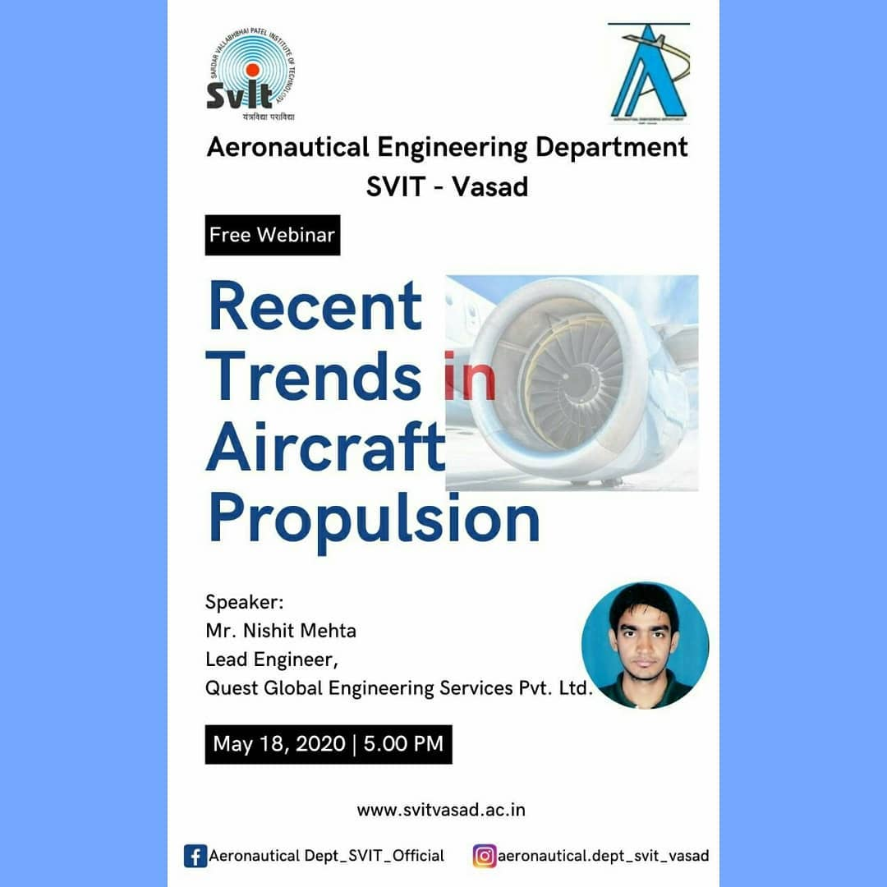 | 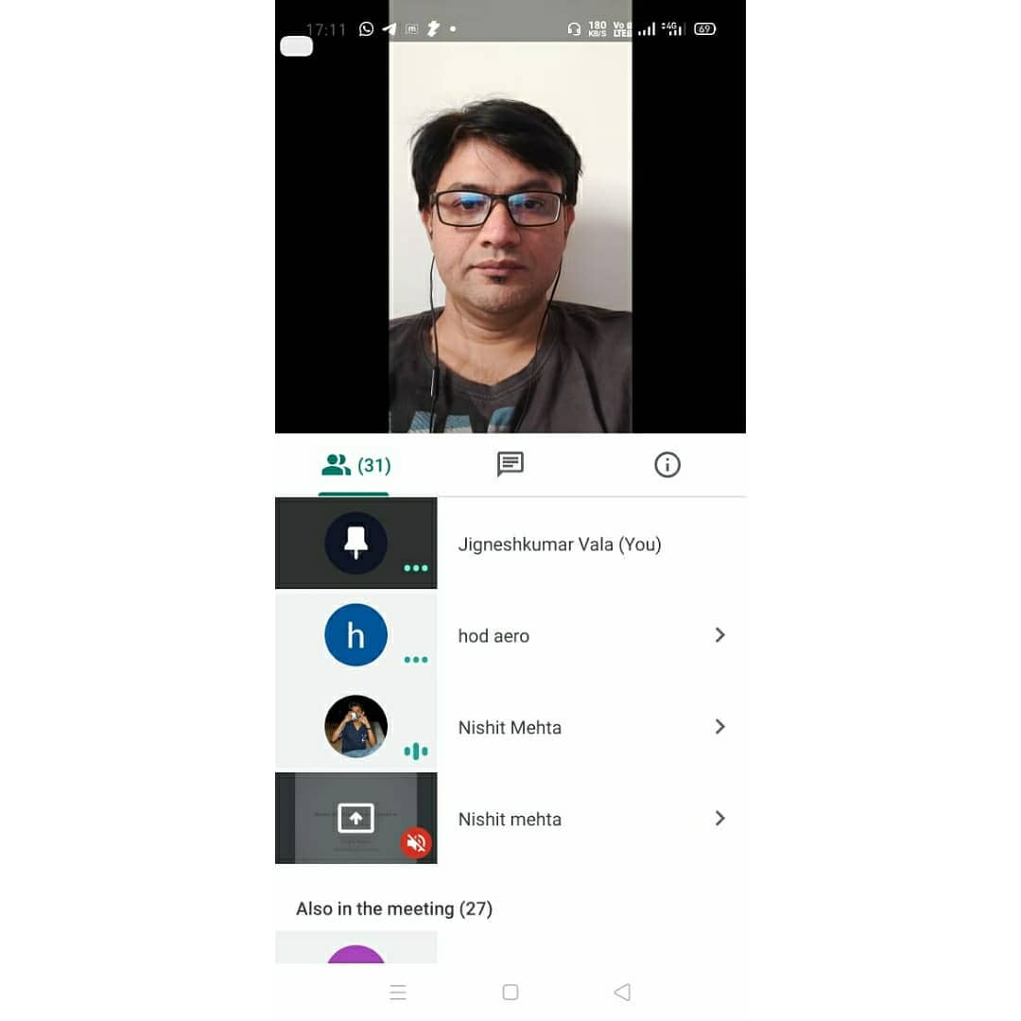

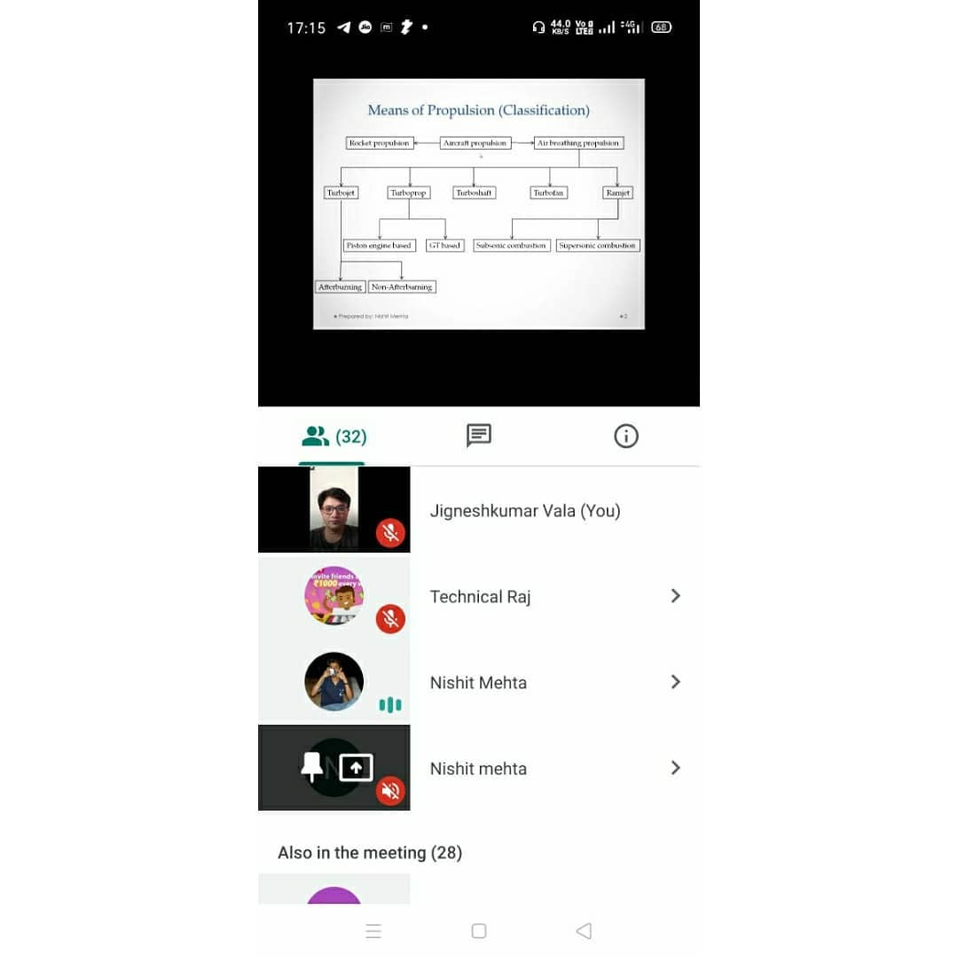 | 