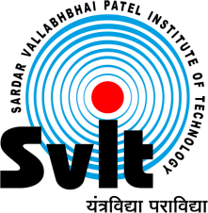
Sardar Vallabhbhai Patel Institute of Technology, Vasad

Aeronautical Engineering Department SVIT-VASAD

Aeronautical engineering department, SVIT Vasad has successfully organized Webinar on "Deep Space Dreams: Making the Impossible Possible" where Ms. Anima Patil Sabale from NASA, USA who has been working as Orion Spacecraft Simulation Lab Manager Engineer discussed challanges in deep space travel . She also guided and motivated students. It was a great opportunity for students to interact with such a great professional. This was a very fruitful and informative session.. Approximately 150 participants were benefited from this webinar.
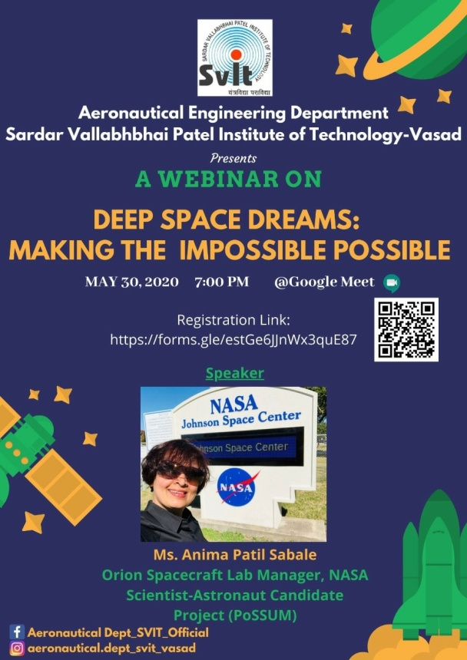 | 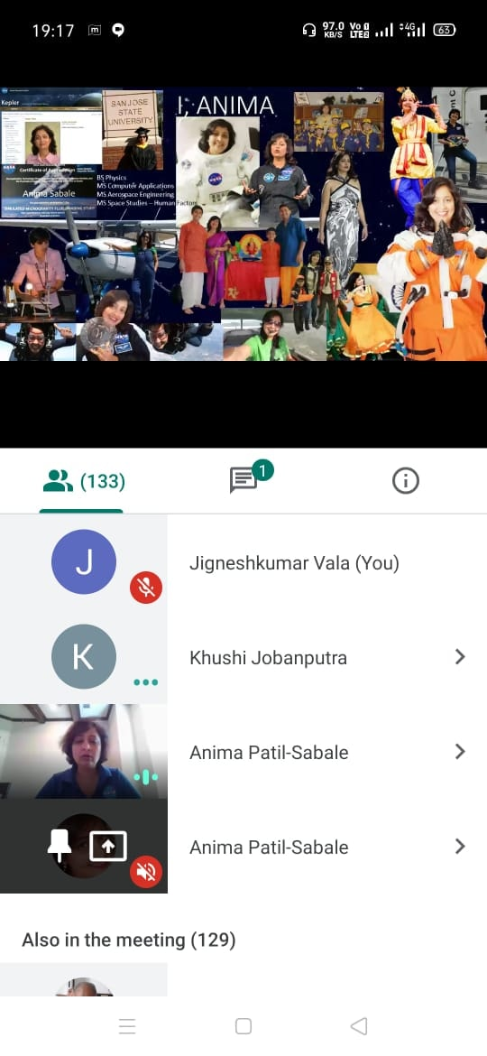

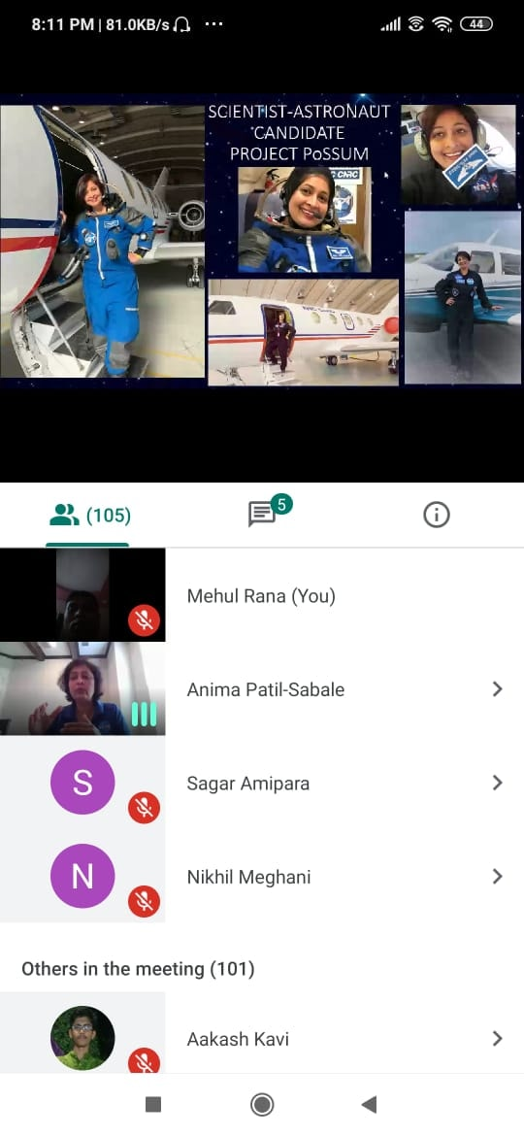 | 