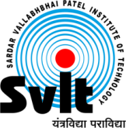
Sardar Vallabhbhai Patel Institute of Technology, Vasad

Aeronautical Engineering Department
Report of Webinar on “Aeronautical Materials and their Characterization”
Aeronautical Engineering Department had organized webinar on “Aeronautical Materials and their Characterization” 21 September, 2020 for all Third year and Final year Aeronautical engineering students. The Expert, Dr. VIJAY KUMAR VARMA, Retd. Scientist 'G' & Group Director (TC & S), DRDO, Min. of Defence, Govt. of India addressed the session. This webinar was organized from 11:00 a.m. to 12:30 p.m. Approximately 57 participants were benefitted from the Webinar. The following points were highlighted during the session. • Materials used in Aeronautical Engg • Materials and their required properties for Airframe, compressor, combustion chamber and turbine • Material testing procedures • Characterization of materials. • Future Materials and job opportunities in Defence and Aviation industry.
Event Photographs:
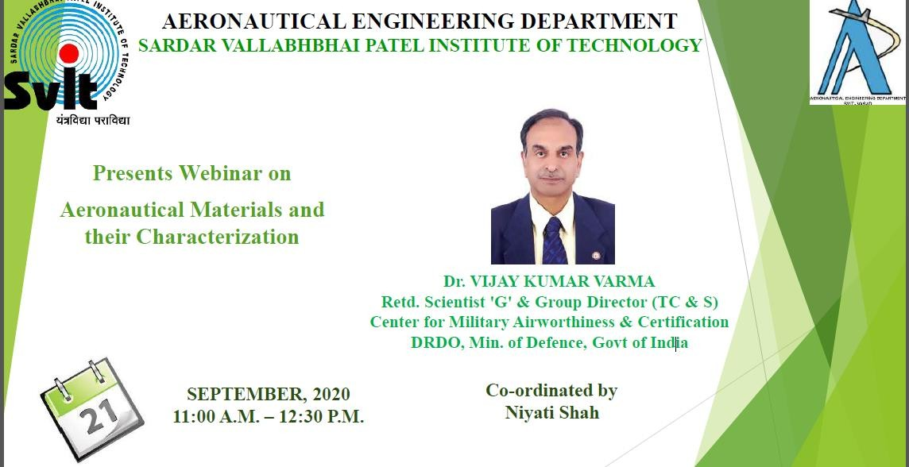

Glimpses of webinar on Aeronautical materials and their characterization
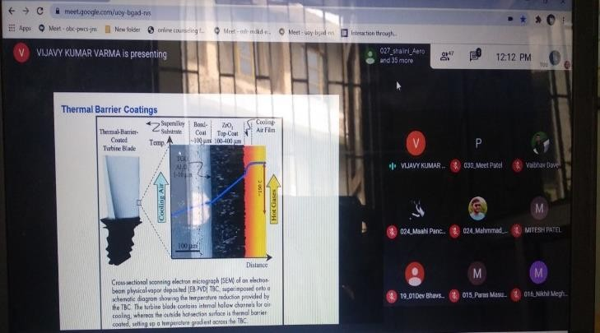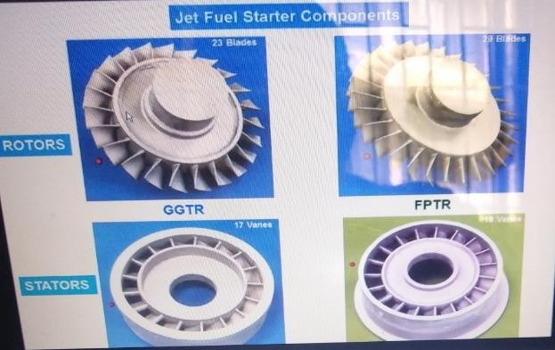

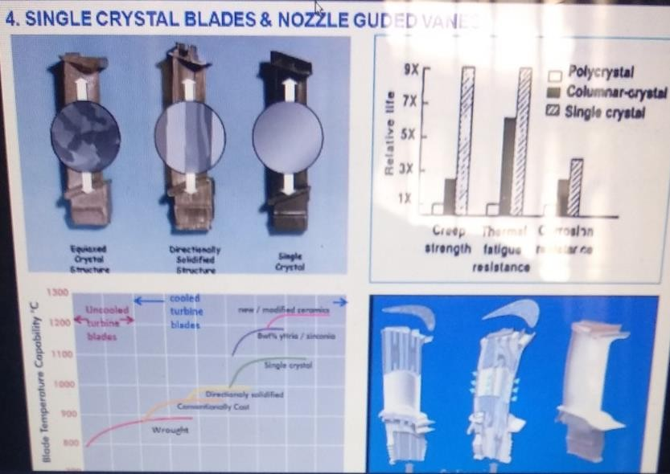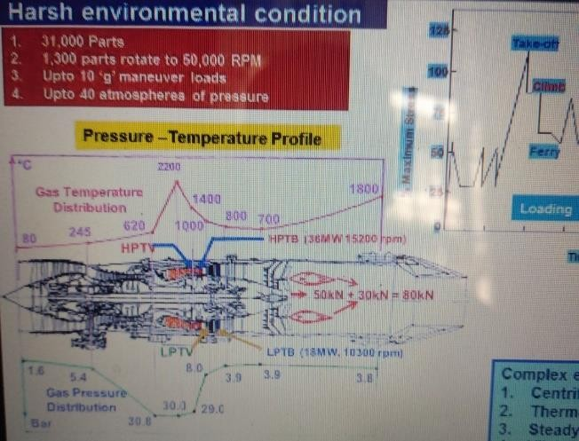

The overall session was very good and informative. Thank You.
Faculty co-ordinator
Niyati Shah Dr. P V Ramana
Assistant Professor Professor and Head
Aeronautical Engg. Dept. Aeronautical Engg. Dept.
SVIT Vasad SVIT Vasad

