 | Sardar Vallabhbhai Patel Institute of Technology  Details of Expert Lecture/Workshop
Name of Speaker | Mr. Saurabh Verma
Designation | Sr. Technical Trainer
Name and Address of Organization | Tops Technologies  905, Samedh Complex, Chimanlal Girdharlal Road, near Associate Petrol Pump, Ellisbridge, Ahmedabad, Gujarat, 380009
Mobile | 9601834396
Email | Saurabhverma.tops@gmail.com
Expertise | UI/UX and Graphics Designer. UI/UX tools like Figma, Adobe Premiere, After Effects, VFX etc.
Date & Day of Expert Lecture | 28/01/2025( Tuesday)
Timing of Expert Lecture | 10:00am to 01:00 pm
Topic | Design a Food Delivery App Home Screen and prototype using Figma.
Names of Coordinators | - Prof. Parul Bakaraniya  - Prof. Brijesh Panchal  - Prof. Priyanka Patel  - Prof. Vihang Patel
Semester | 4th and 6th CE and CSD Students
Discipline | Computer Engineering, Computer Science and Design Engineering.
Academic Year | 2024-25
No. of Students Present | 132
How this lecture was useful to students for strengthening their knowledge? | This session has focused on the UI/UX basic concepts and it’s Software tools. Expert has demonstrated the “Design a Food Delivery App Home Screen and prototype” using Figma. Expert has explained different methods and control to generate design layout of application. He has focused on Generative AI and it’s tools and given the awareness about different job profile in Design domain.
Identify 4 students who actively participated during activities of expert lecture. | Criteria for identification:-  Interaction Documentation  Discussion Leadership Learning  1. Arpita Nathwani 2. Mahi Gandhi  3. Shreel Gandhi 4. Mihir Prajapati
PICTURES OF EVENT | Photo 1: (Experts on dias )  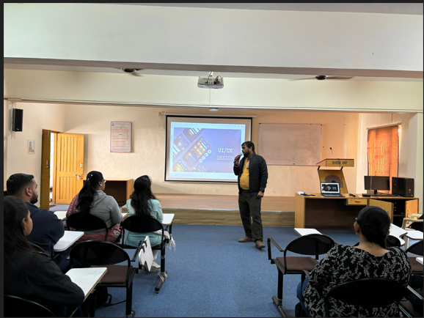 | Photo 2: (image of event)  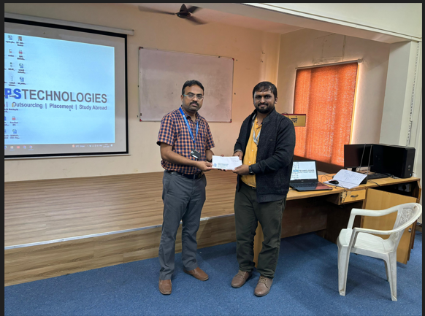
 | Photo 3: (Experts delivering lecture)  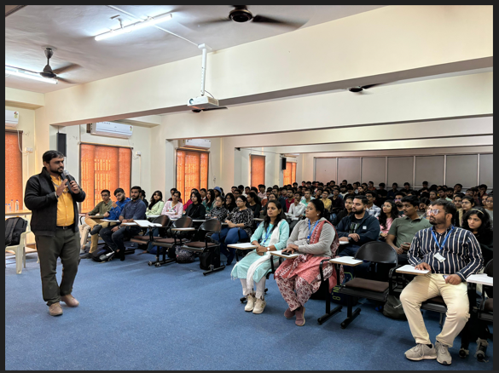 | Photo 4: (Audience in hall visible)  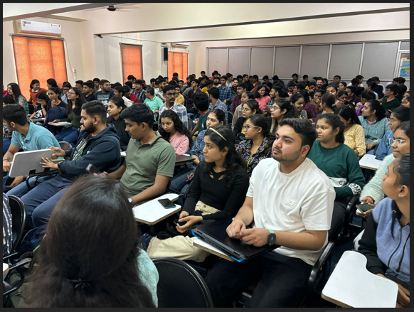
Note:-
- Submit report to HOD, Newsletter Editor

Name of Coordinator H.O.D-CE H.O.D.-CSD
- Prof. Parul Bakaraniya Prof. Jayna Shah Dr. Ajaysinh D. Rathod
- Prof. Brijesh Panchal
- Prof. Priyanka Patel
- Prof. Vihang Patel

