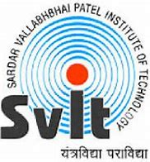 | Sardar Vallabhbhai Patel Institute of Technology  Details of Industrial Visit

Name of Industry / Organization | MATRIX COMSEC
Address of Industry/Organization | 19-GIDC, Waghodia,
Address of Industry/Organization | Dist. Vadodara-391 760
Address of Industry/Organization | Gujarat, India.
Contact Person | Mrs.Helly Jagtap
Contact No. | ‎+91 95120 47415
Email
Date & Day of Industrial Visit | 13th September 2024
Timing of Industrial Visit | 10:00 AM to 02:00 PM
Semester | IV
Discipline | CE I, CE II, CE III,CSD
Academic Year | 2024-2025
Nos. of Students Present | 38
Names of Faculties accompanied to students | 1. Prof. Arpit Mehta  2. Prof. Priyanka Patel
What was observed during Industrial Visit? | 1. Video Surveillance Systems Department
What was observed during Industrial Visit? | 2. Access Control and Time-Attendance Systems Department
What was observed during Industrial Visit? | 3. VoIP and Communication Endpoints Department
How this visit was useful to students for strengthening their practical understanding? | An Industrial visit to MATRIX COMSEC, an Innovator in Telecom and Security Solutions was organized by Sardar Vallabhbhai Patel Institute of Technology for Computer Science Department second year students on 13th September 2024.  Prof. Arpit Mehta and Prof. Priyanka Patel accompanied the students for the Industrial visit to understand the processes at the manufacturing unit. Matrix is a leader in Security and Telecom solutions for modern businesses and enterprises. As an innovative, technology driven and customer focused organization, the company is committed to keeping pace with the revolutions in the Security and Telecom industries.  With around 40% of its human resources dedicated to the development of new products, Matrix has launched cutting-edge products like Video Surveillance Systems - Video Management System, Network Video Recorder and IP Camera, Access Control and Time-Attendance Systems as well as Telecom Solutions such as Unified Communications, VoIP and Communication Endpoints.  These solutions are feature-rich, reliable and conform to international standards. Based at Waghodia, Vadodara in India, the Matrix manufacturing unit is operated by a well-qualified and dedicated team of engineers. Spread over an area of 73,000 sq. ft., the structure houses departments like Assembly, Testing, Quality Control, Purchase, Stores, Despatch and Accounts. Matrix has a production capacity of about 10,00,000 ports per annum. The factory also houses a full-fledged technical support centre spread over an area of 10,000 sq. ft., manned by well-trained and efficient engineers.  The centre provides immediate technical assistance to Matrix channel partners and customers during installation, operation and maintenance of the product. Students got all the relevant insights about the company, from Mr. Mahesh Pandya, Matrix Comsec. Initially, Mr. Mahesh Pandya took an introductory session, wherein he explained the processes, subprocesses relevant to the industry and competitors.  He also explained the process of export of Matrix Comsec products. Students got the chance to visit towards the manufacturing area where they were exposed to see various minute raw materials used for the manufacturing the final product. The company manufactures almost 200 products, with requirement of 5000 type of different raw materials. Handling such raw materials is a task by itself. Students also visited the packaging department along with assembly line of final product. Students were exposed to assembly line of biometric thumb impression machine, along with its labelling and final packaging.  The visit was concluded with a question-answer session. Students asked various questions related to the technical aspects of the company which was answered by Mr. Mahesh Pandya.
Identify 4 students who actively participated during visit. | Criteria for identification:-  Interaction Leadership Documentation  Discipline Dress Code other(specify)  - Rutu M Shah.  - Ansh Pandya.  - Harsh Makwana.  - Raj Kaushal Shah.
Pictures of event | Photo 1:(Location of industry with landmark)  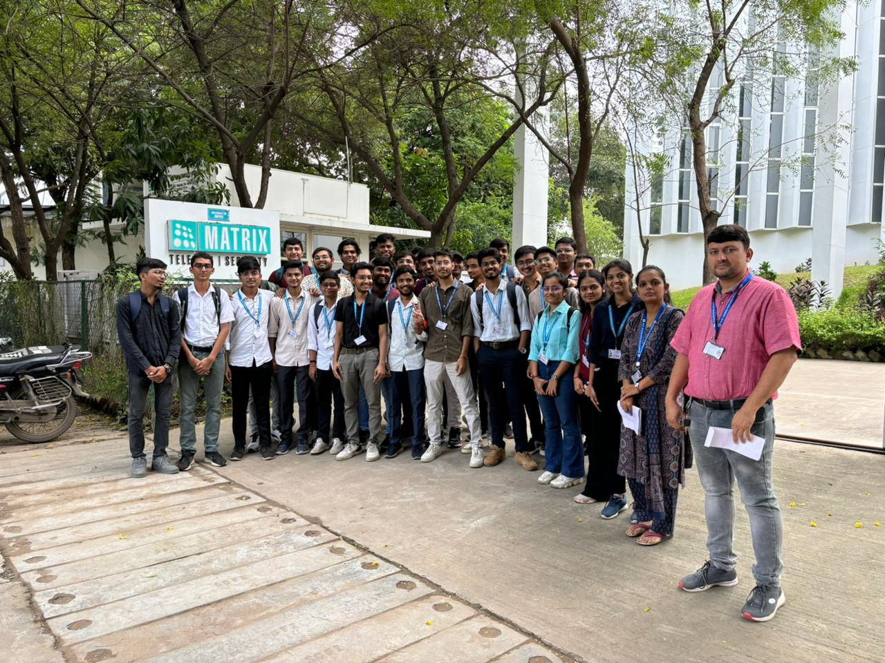 | Photo 2:  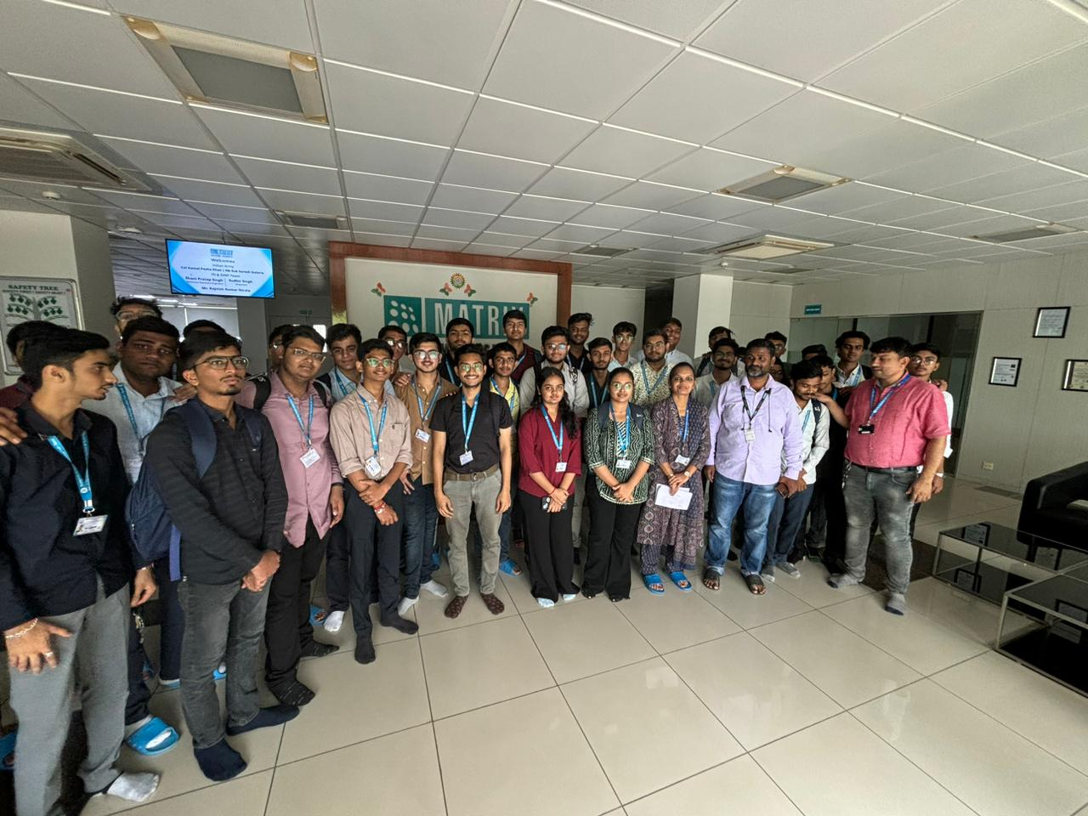
Pictures of event | Photo 3:( Students visit the work area)  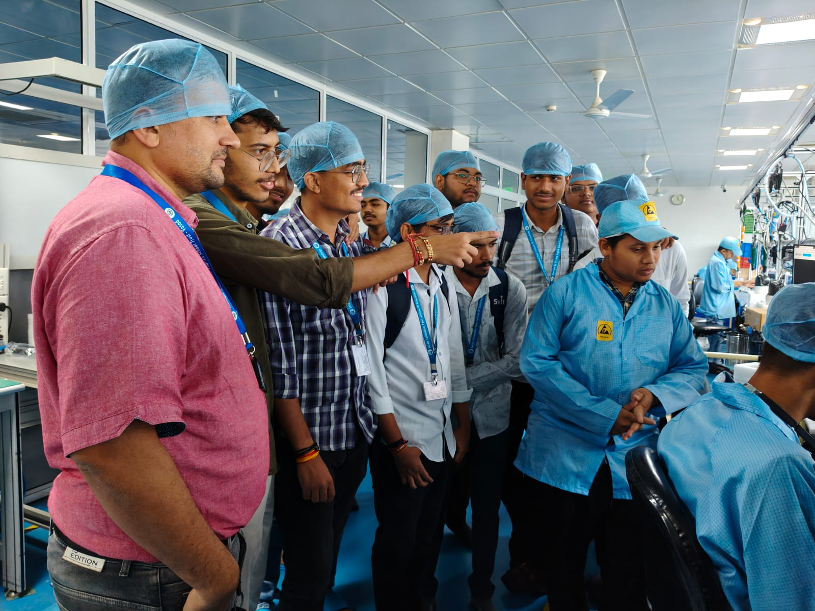 | Photo 4: ( Students visit the work area) 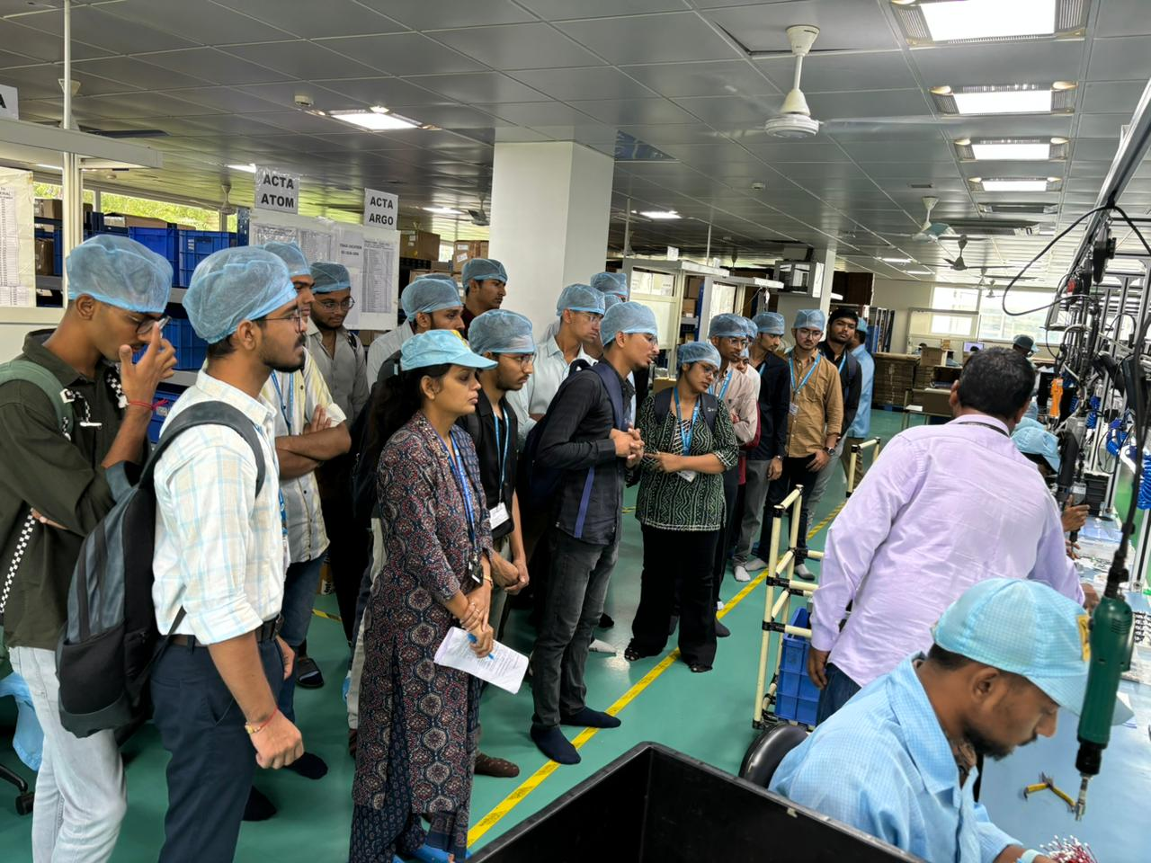
Note:-
Capture 4 photographs for the format as below:
  - Photo 1: Location of industry with landmark1
  - Photo 2: Location of industry with landmark2
  - Photo 3: Students visit the work area of VoIP and Communication Endpoints Department
  - Photo 4: Students visit the work area of Video Surveillance Systems Department

- Submit report to HOD, and Newsletter Editor

Date of Submission of Report: Name of Coordinator: H.O.D
Prof. Parul Bakaraniya Dr. Neha Soni
Prof. Vihang Patel Dr.Ajay Rathod
Prof. Brijiesh Panchal
Prof. Priyanka Patel

