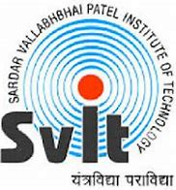 | Sardar Vallabhbhai Patel Institute of Technology-VASAD  Details of Maker Fest’25 Visit

Name of Industry / Organization | Maker Fest 2025, Vadodara
Address of Industry/Organization | Faculty of Technology & Engineering,  M.S. University, Kalabhavan,  Vadodara, Gujarat.
Contact Person | ---
Contact No. | ---
Email | ----
Date & Day of Industrial Visit | 8th February, 2025
Timing of Industrial Visit | 10AM to 2:00 PM
Semester | IV, VI
Discipline | CE and CSD
Academic Year | 2024-2025 (EVEN)
Nos. of Students Present | 10
Names of Faculties accompanied to students | 1. Prof. Parul Bakaraniya  2. Prof. Rajvee Desai
What was observed during Industrial Visit? | Visited different stalls of Projects like “ Robots” from SVIT-VASAD, “ Under water sensor device”, “ Drone”, “ML/DL projects in Healthcare” , “ Robotics project” etc. and interacted with various technocrats to know about different current trends and technologies for CE/IT students. Interacted with some company owners like “ CIBOS Technosolutions pvt ltd” etc.
How this visit was useful to students for strengthening their practical understanding? | Maker Fest is an Indian version of the global Maker Faire movement, which began in California in 2006. Creators from different walks of life such as tech enthusiasts, artists, educators, tinkerers, hobbyists, engineers, science experimenters, fusionists, environmentalists, food artisans, and early-stage startups participate as Makers. Makers showcase their captivating creations, and those who attend get a sneak peek into the future. It’s not just about observing – it’s a place to spark your inner maker and learn how to make your own ideas a reality! SVIT Institute’s 1 group from CE get Silver prize of 12,500 rs in makerfest25.
Identify 4 students who actively participated during visit. | Criteria for identification:-  Interaction Leadership Documentation  Discipline Dress Code other(specify)  - Het Zinzuvadiya  - Krutarth patel  - Sharnam Shah  - Aksha Katwala
Pictures of event | Photo 1:(Location of Makerfest’24 with landmark) 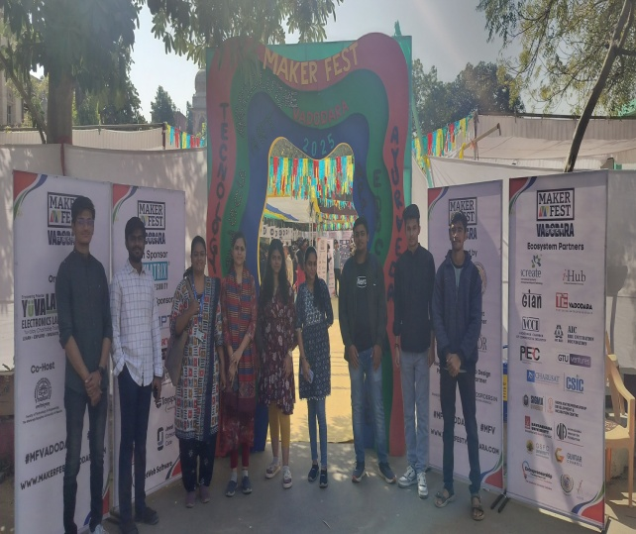 | Photo 2: (Interaction with SVIT CE/IT Winner team ) 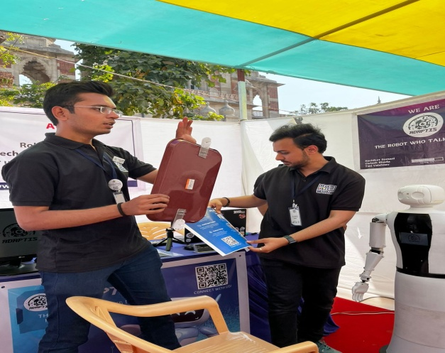
 | Photo 3:(Students Interaction about Project)  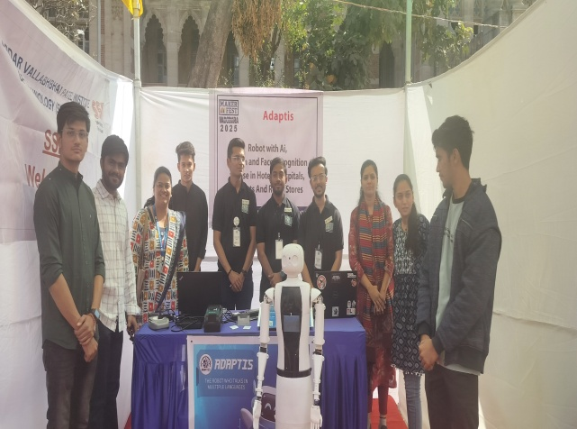 | Photo 4: (Interaction in technical video lect after Inauguration function) 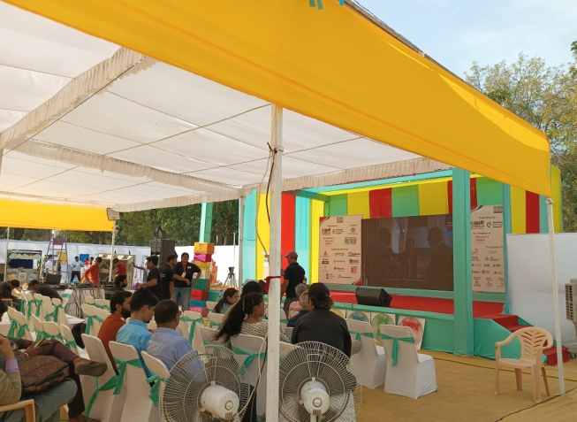

Name of Coordinator: H.O.D-CE H.O.D-CSD
Prof. Parul Bakaraniya Prof. Jayna Shah Dr. Ajaysinh D. Rathod
Prof. Brijesh Panchal
Prof. Priyanka Patel
Prof. Vihang PAtel

