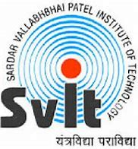 | Sardar Vallabhbhai Patel Institute of Technology  Details of Industrial Visit

Name of Industry / Organization | International Centre for Entrepreneurship and Technology , Ahmedabad
Address of Industry/Organization | Opp. Kensville Golf Club & Resort, Off Bavla Rajkot Highway,
Address of Industry/Organization | Deo Dholera Village, Ahmedabad
Address of Industry/Organization | Gujarat, India.
Contact Person | Mr. Hiren Yadav
Contact No. | ‎+91 9898909214
Email | info@icreate.org.in
Date & Day of Industrial Visit | 6th March 2025
Timing of Industrial Visit | 10:00 AM to 02:00 PM
Semester | VI
Discipline | CE I, CE II, CE III,CSD
Academic Year | 2024-2025 EVEN
Nos. of Students Present | 52
Names of Faculties accompanied to students | 1. Prof. Urmila Khunt  2. Prof. Milind Shah
What was observed during Industrial Visit? | Innovation & Startup Ecosystem – iCreate fosters a strong ecosystem for startups by providing mentorship, funding, and technical support to innovative entrepreneurs.
What was observed during Industrial Visit? | Advanced Facilities & Prototyping Labs – The center is equipped with cutting-edge technology, including IoT labs, AI research spaces, and rapid prototyping tools to help startups develop and test their products.
What was observed during Industrial Visit? | Industry Collaboration & Real-World Applications – iCreate collaborates with various industries and government initiatives, bridging the gap between academic research and practical industrial solutions.
How this visit was useful to students for strengthening their practical understanding? | An Industrial visit to iCreate, an International Centre for Entrepreneurship and Technology was organized by Sardar Vallabhbhai Patel Institute of Technology for Computer Engineering and Computer Science & Design Department third year students on 6th March 2025.  The industrial visit to iCreate was highly beneficial for students in strengthening their practical understanding of innovation and entrepreneurship. Dr. Saiyed provided insightful explanations about the startup ecosystem, technological advancements, and various opportunities available for young innovators. His detailed discussion on real-world applications of IoT, AI, and rapid prototyping helped students bridge the gap between theoretical knowledge and industrial practices. Professors Urmila Khunt and Miind Shah accompanied the students, ensuring they grasped key concepts and actively engaged in discussions. The visit provided hands-on exposure to cutting-edge facilities, fostering a deeper understanding of how innovative ideas are transformed into viable businesses.
Identify 4 students who actively participated during visit. | Criteria for identification:-  Interaction Leadership Documentation  Discipline Dress Code other(specify)  - Khushi Girishbhai Prajapati  - Jeet Shah  - Nachiket Somani  - Nidhi Agrawal
Pictures of event | Photo 1:(Location of industry with landmark)  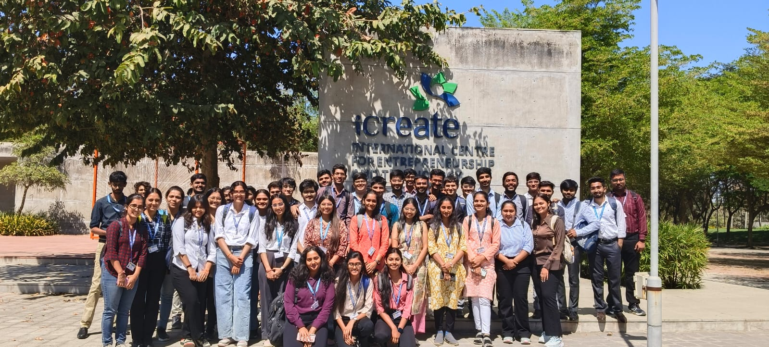 | Photo 2:  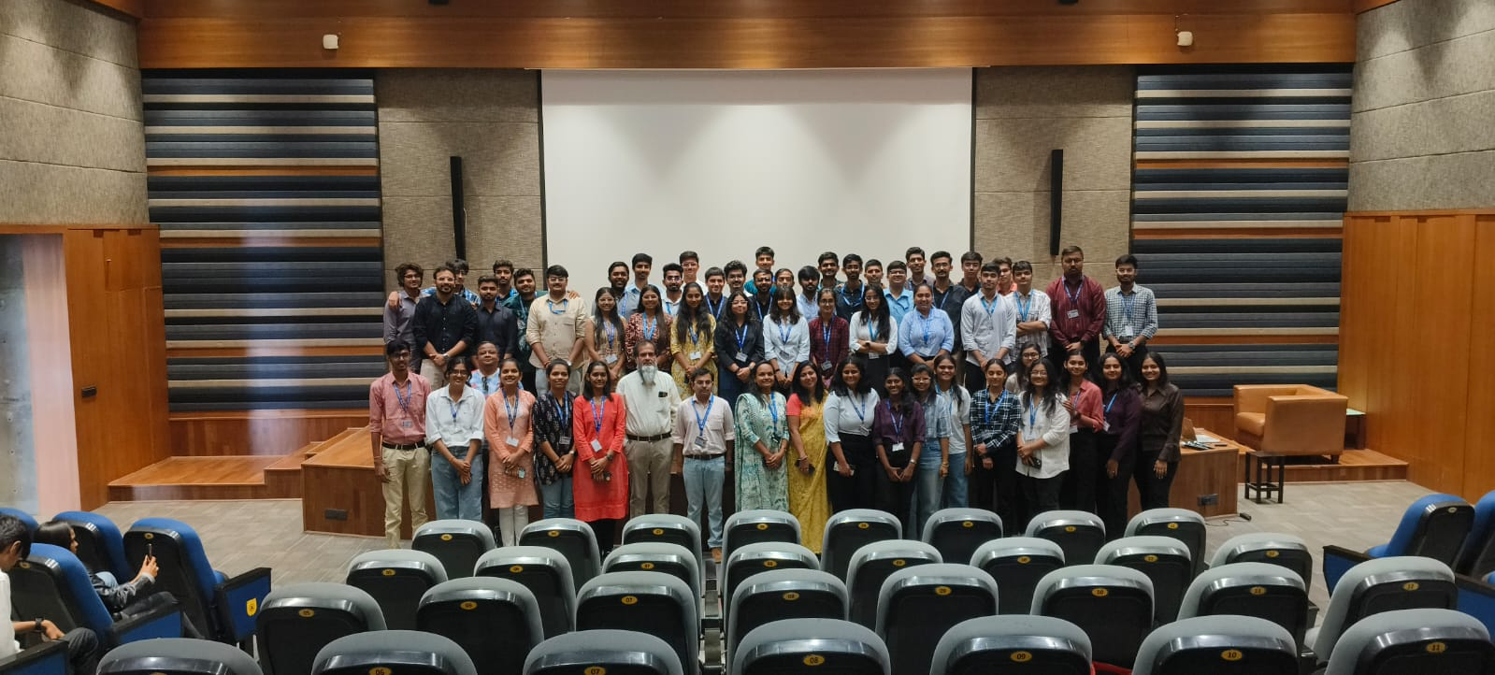
Pictures of event | Photo 3:( Students share there idea)  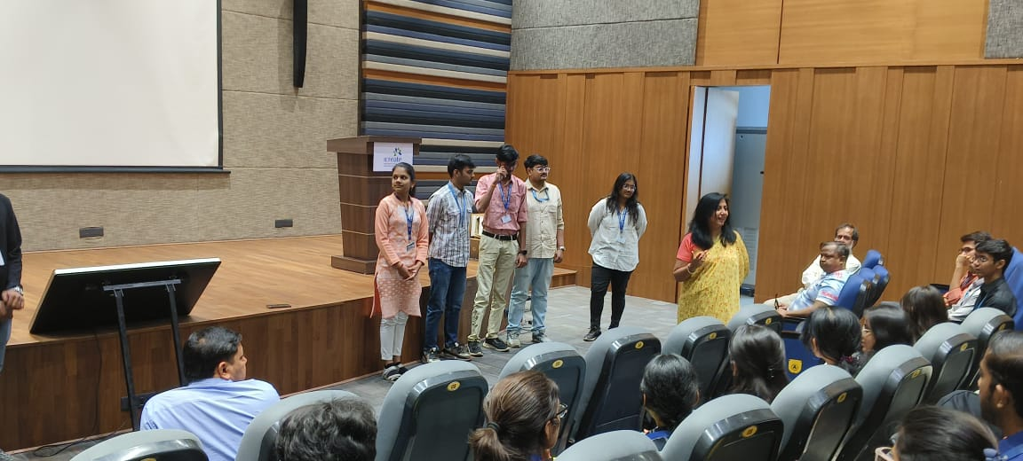 | Photo 4: ( Students share there idea) 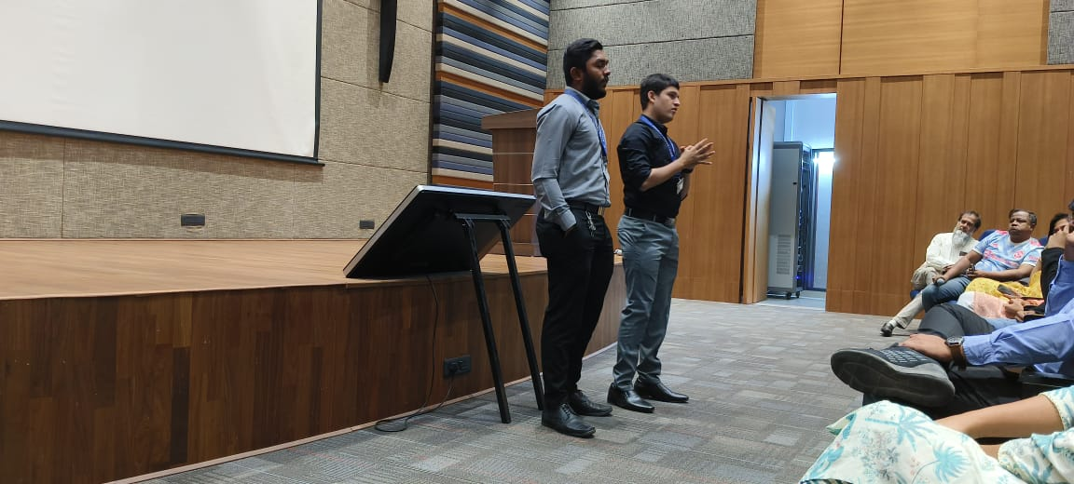

Name of Coordinators: H.O.D-CE H.O.D-CSD
Prof. Parul Bakaraniya Prof. Jayna Shah Dr. Ajaysinh Rathod
Prof. Vihang Patel
Prof. Priyanka Patel
Prof. Brijesh Panchal

